# Radar System

*Omkar Anand Iyer*

*EC23B1075*

**Components used:**

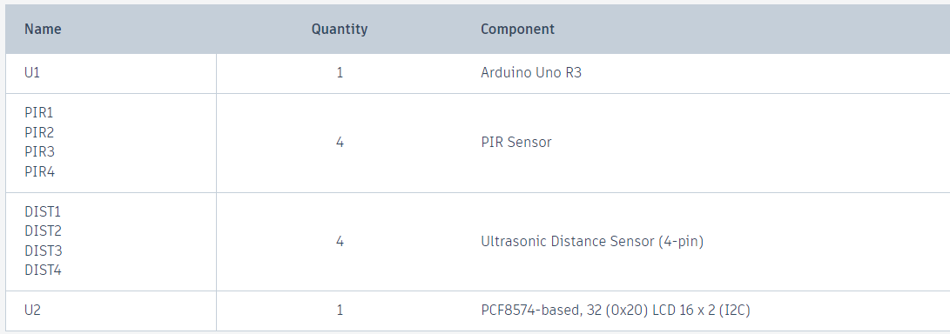

**Working:**

In this project the PIR sensors detect the presence of a moving object in a particular direction. The ultrasonic sensor in that direction is then turned On and the distance of moving object is calculated.

**Picture**

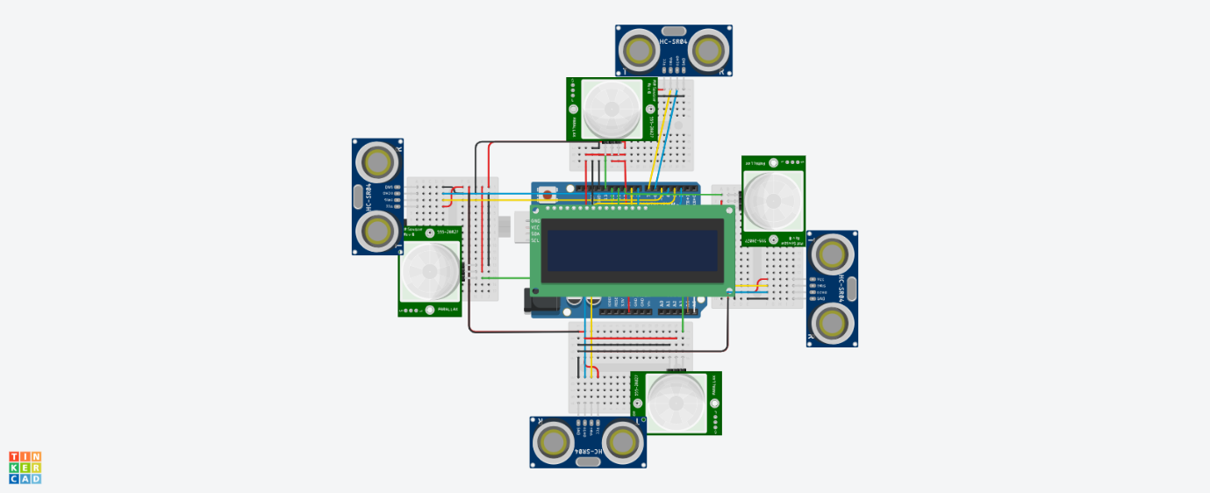

**TinkerCad Link:** https://www.tinkercad.com/things/fgXqWFdkTPV-radar-system-?sharecode=s0aeWrS9bWD5pu4LzllHvVWJfpHOz4p7gUeNRJP1QfI